SKILL

AND

JOB

RECOMMENDER

PN

T2022

TMID41796

**Setting**

**up**

**Application**

**Environment**

**Docker**

**CLI**

**Installation**

Date

2

7

October

2022

Team

ID

PNT2022TMID41796

Project

Name

Skill/Job

Recommender

Application

**Step**

**1.**

Download

Docker

from

docker.com

and

install

it

by

running

the

Docker

Desktop

Installer.exe

file

**Step**

**2.**

Goto

hub.docker.com

register

and

create

an

account

and

login

with

thesame

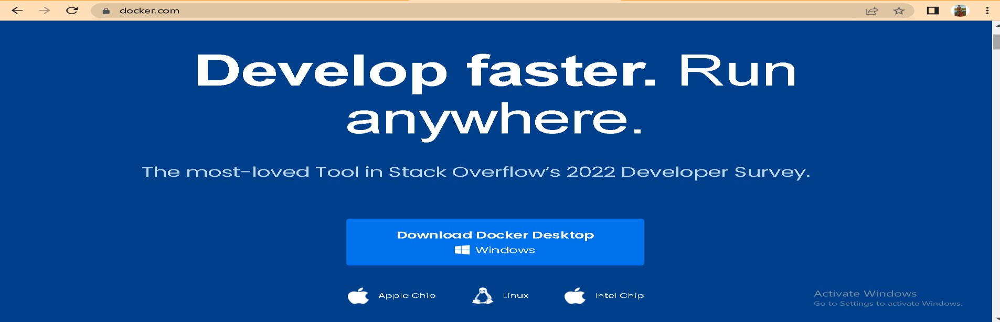

SKILL

AND

JOB

RECOMMENDER

PN

T2022

T

M

I

D

41796

**Step**

**3.**

Open

Docker

Desktop

and

start

creating

containers

and

images

